Region 6

Regional Response Team (RRT)/Joint Response Team (JRT)

Activation Guidance for Poison Centers (Region 6)

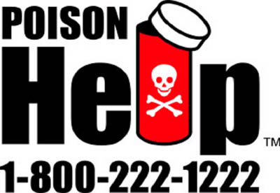 | 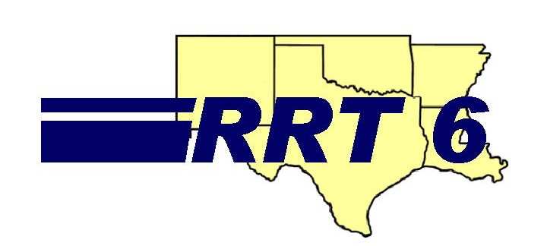
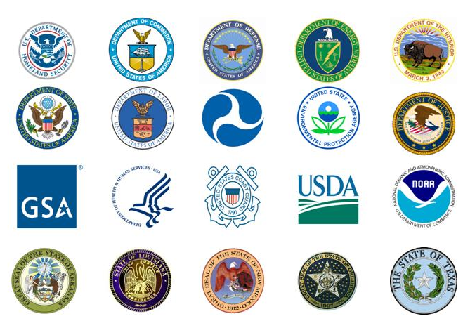
October, 2011
V-14

Regional Response Team Members On-Scene Coordinator (OSC)

Lead - Inland Spills


Lead - Coastal or Navigable Waterway

Introduction:

Poison Centers (PC), often called “poison control centers”, has historically been unrecognized in the preparedness and response community as a major player in the role of protecting the health of our population during hazardous materials incidents or terrorist events. Functioning on a very limited patchwork of local, state and federal funding, Poison Centers have provided vital health services to the general public and health care professionals for over 30 plus years. The PC provision of direct 24 hour patient care services to residential callers, health care professionals and institutions adds value to the services provided by many government public health entities, health care providers and commercial insurance carriers. Not only can the PCs provide medical evaluation and consultation, they also save the states substantial money by reducing the number of hospital ER visits because they can asses and often treat cases at home, saving the States hundreds of thousands of dollars each year.

The Region 6 Regional Response Team (RRT6), Co-Chaired by the US Environmental Protection Agency (EPA) and the US Coast Guard is the federal component of the National Response System for the states of Arkansas, Louisiana, New Mexico, Oklahoma, and Texas. RRT6 is composed of representatives from sixteen (16) federal departments and agencies and each of the five States. In addition, Region 6 shares its southern border with the country of Mexico. Similar to the RRT, a Joint Response Team (JRT) is established along the US/Mexico border consisting of federal, state and local agencies involved in chemical emergency prevention, preparedness and response on both land and water.

RRT6 has recognized the potential value and contributions that PCs offer to the National Response System and drafted this interim guidance document for use of PCs within its jurisdiction, and for consideration as a national guidance document by the National Response Team (NRT).

What are Poison Centers?
In the United States, PC(s) provide immediate treatment advice for poison emergencies. PC centers are staffed 24-hours a day by nurses, physicians, pharmacists and other highly trained healthcare professionals. The PC staff offer expertise in the areas of chemical, environmental, radiological, oil spills, biological, and agricultural hazardous materials to all public health entities, environmental agencies, hospitals, on-scene responders, and the general public. PCs also have skilled linguists that can overcome multiple language barriers. The Poison Centers in Region 6 have staff to handle Spanish speaking callers to reflect the communication and collaboration efforts between the PCs and the Hispanic population, to include bi-national collaboration with Mexico.

Which Poison Center can be used?
There are ten (10) PCs in Region 6; one (1) each in New Mexico, Oklahoma, Arkansas and Louisiana and a network of six (6) inter-connected centers in Texas. The PCs in Region 6 can be contacted to assist the RRT and its member stakeholders address public health issues within their respective states or even in the event of a national disaster.

To contact a Poison Center just call the toll free national number 1-800-222-1222 from a landline phone system within the State in which the disaster has occurred. Or contact the PC directly through the non-emergency office phone number listed at the end of this document. Note: Cell phones can be used. However, the cell phone area code might route a caller to a Poison Center based on the area code the cell phone or Black Berry devise is registered. Regardless, calls can be re-routed back to the state in which the event has occurred.

In the event of major spill or event that causes the activity to be designated a Spill of National Significance, a single PC should take the lead role and be the Point of Contact (POC) during the event. Other PC(s) should support the lead PC by providing call data on a daily basis. The Lead PC will have the responsibility of coordinating with the American Association of Poison Control Center (AAPCC) and the National Poison Data System (NPDS) to establish a “event code” for tracking; establish email communication links with State and Federal Response partners to include other Poison Centers; and, creating a daily Situation Reports (SIT Reps) for surveillance monitoring (see Attachment 1 example).

When can Poison Center be used?
Poison Centers are available to receive calls 24 hours a day, 7 days a week; thus, PCs are available to receive telephone calls during all phases of a disaster. Poison Centers are accessible to anyone calling from within their state. Poison Centers can receive calls from the public, 911 operator/dispatcher, impacted citizens, the media, receiving hospitals, private industry, physicians, state/county health departments’, state/county environmental agencies, federal environmental and health agencies, and emergency managers from local, state and federal agencies.

How can a Poison Center assist the Regional Response Team and Joint Response Team?
Poison Centers have legally designated authority to address and to provide treatment recommendations to the people exposed to all types of poisons; this includes occupational exposures to hazardous materials. They also are available to serve as a vehicle for communicating information to callers during disaster events. This communication system also provides a broader approach to addressing the general public not impacted by the event and may include concerned citizens, politicians and the media. Poison Centers have the ability to report epidemiological information based on community calls that can be used to gage the concerns of the communities impacted. Both the RRT and JRT, and their member agencies, can utilize the expertise of the PC(s) to address human exposures due to any and all hazardous materials emergency events. In addition, the poison centers have the ability to track calls received calls, providing invaluable epidemiological data that often times are not received from hospital systems (no patients reporting to clinics/hospitals).

What types of incidents would involve a Poison Center?
PCs are available to assist local, state, and federal agencies by providing a public telephone-based service for any type of incident where hazardous materials may threaten the public health. These incidents might include only localized impacts that are managed by local fire, police, and EMS. Or even larger events that involve State emergency response programs and disasters that require Federal assistance. Spills of National Significance may require support from multiple State Poison Centers. Hazards addressed could be anything from a toxic industrial chemical release resulting from a chemical facility fire, to household hazardous waste such as pesticides, mercury thermometers, or oily residues that might be encountered by residents re-entering flooded neighborhoods caused by natural disasters, major oil spill or a Chemical/Biological/Radiological/Nuclear (CBRN) event.

How Can Poison Center function within the Incident Command System?
The Incident Command System (ICS) is the response management structure used by all emergency response organizations, as described in the National Response Framework (NRF). The ICS establishes positions that accomplish the key functions of incident management, including command, operations, planning, logistics, and finance. PC may interact with many of these positions during the course of an incident. The initial decision to activate a PC would probably be made by the Incident Commander (IC). However, because the PC system is public, the call centers may already be activated by the public calling the centers. The activation of a PC may be publicly announced by a Public Information Officer (PIO), and/or an Agency Liaison Officer (LNO). Once activated, a PC would need information on the nature and extent of potential hazards involved, which could be provided by the Planning Section, and particularly, the Situation Unit. In turn, the PC could then offer advice on safety and treatment of potential exposures to the Safety Officer and Operations Section. If the event generates news media or political interest, it may be necessary to involve a Joint Information Center (JIC) in developing public statements for PC to use during calls received from the public. This may be elevated to the National Information Center (NIC) during events of National Significance.

Poison Centers should familiarize their staffs with Incident Command System (ICS) principles so that they can interact appropriately within the Incident Command System. To determine what level of training an individual needs according to their level of responsibility during a multi-jurisdiction, multi-agency, multi-discipline incident, please review the FEMA web site: www.fema.gov/pdf/emergency/nims/TrainingGdlMatrix.pdf

What information would a Poison Center need from emergency response agencies?
Poison Centers can be used to provide treatment recommendations to callers at home, in a hospital setting or shelters. Seeking help from a PC by phone can help alleviate patient surges to local healthcare facilities. In order to make informative decisions, the agency(s) that activate the PC should provide any data (environmental/public health) that can assist them to better respond to public inquiries.

The following information might become available through ICS liaisons and may include:

- notification from spill reports
- exact location of spill and/or releases
- amount of material spilled and type
- potential health/environment impacts
- plume maps
- weather conditions
- fact sheets
- sensitive populations (children, elderly, child bearing, etc)
- contamination maps/zone of contamination
- site photos
- sensitive issue (terrorism events, national disasters, political, etc)

What information can PCC’s provide to incident command staff during and after an incident?
In addition to providing toxicology advice, PCs generate certain data as a routine course of their duties that can be very useful to incident command staff. As PCs begin to respond to calls from the public, they record information on the identities, numbers of callers, location where exposures may have occurred, and symptoms observed/reported. They also track the progress of persons they refer for medical treatment through the treatment process. This information can assist incident management staff in identifying potentially exposed populations and areas of contamination, which are necessary for developing effective response and mitigation strategies.

How might Poison Centers be used to support a disaster of National Significance or a Spill of National Significance (SON)?

There are 57 poison centers in the U.S. serving all residents. While not formally connected, all poison centers share a common emergency hotline number 1-800-222-1222. If one center is overwhelmed with call volume poison centers have the ability to transfer a portion of calls to another or multiple poison centers. All poison centers have a disaster routing plans in place. Poison Centers are encouraged to have at least two alternate Poison Centers designated to help manage excess call volumes if needed. Those centers are designated in another region of their state or of the U.S. in case a regional event overwhelms centers in the same area. Through this call sharing capability, a tremendous number of phone calls can be distributed to other Poison Centers, thus providing impressive surge capability. Calls can be re-routed from one center to another or multiple centers in less than 15 minutes, if needed. This ability is currently for centers to transfer calls and conduct staff meetings or continuing education so that all staff members may attend. In the event of a Spill of National Significance (SON) where by multiple states will be impacted, the Poison Center should contact the American Association of Poison Control Centers (AAPCC) and request a code in order to track all calls to the event. Call center staff should be trained on the event and use of the designated code to facilitate call tracking.

Poison Centers have the only real time 24-hour a day medical surveillance system in the U.S. Poison Centers use syndromic surveillance to monitor data from all poison centers for emerging health threats and concerns. These include, but certainly are not limited to syndromes monitoring for possible cases of chemical and biological terrorist threats. If the criteria for a certain syndrome are met, an anomaly alert is generated. A national surveillance team analyzes the case or cases that triggered the alert. Additional information may be requested from poison centers where the cases originated. If a public health concern is found the appropriate health authorities are immediately notified.

How are funding issues addressed when Poison Center respond to a disaster?
- RRT/JRT Response Team Activation Guidance for Poison Centers

  - Incident Commanders request resources first at the local level

  - If resources are not available at the local level, mayors/county judges may request assistance from the Governor. (PC should keep detailed records of all time and expenditures during an event).

  - If resources are not available at the state level, the Governor may request assistance from other states, or

  - If resources are not available at the state level, the Governor may request assistance from the President

  - In order for a state to provide resources to another state, an Emergency Management Assistance Compact (EMAC) is required

    - EMERGENCY MANAGEMENT ASSISTANCE COMPACTS (EMAC)

- All states in FEMA Region VI have legislatively enacted the EMAC agreement

- EMAC's provide form and structure for interstate mutual aid

- EMAC’s quickly/efficiently resolve two key issues upfront: liability and reimbursement

- Only authorized representatives (Governor or designee) may request assistance from another state

  - Disaster impacted state can request and receive assistance from other member states
  - States rendering aid shall be reimbursed by the state receiving aid
  - States rendering aid may withhold resources to provide reasonable protection of their state resources

- REIMBURSEMENT

  - In accordance with the EMAC’s, states rendering aid shall be reimbursed for all costs by the state receiving aid

  - In presidential declared disasters, FEMA reimburses impacted states on a cost-reimbursable basis

- Pursuant to the Stafford Act, division of costs among Federal, State, and local governments is a negotiable item
- The minimum federal share under the Stafford Act is 75%.
- However, depending on the circumstances, the Federal government may assume a larger percentage of the costs
- No dollars are sent directly from the impacted state to Poison Control Answering Points

(SITUATION REPORT Example)
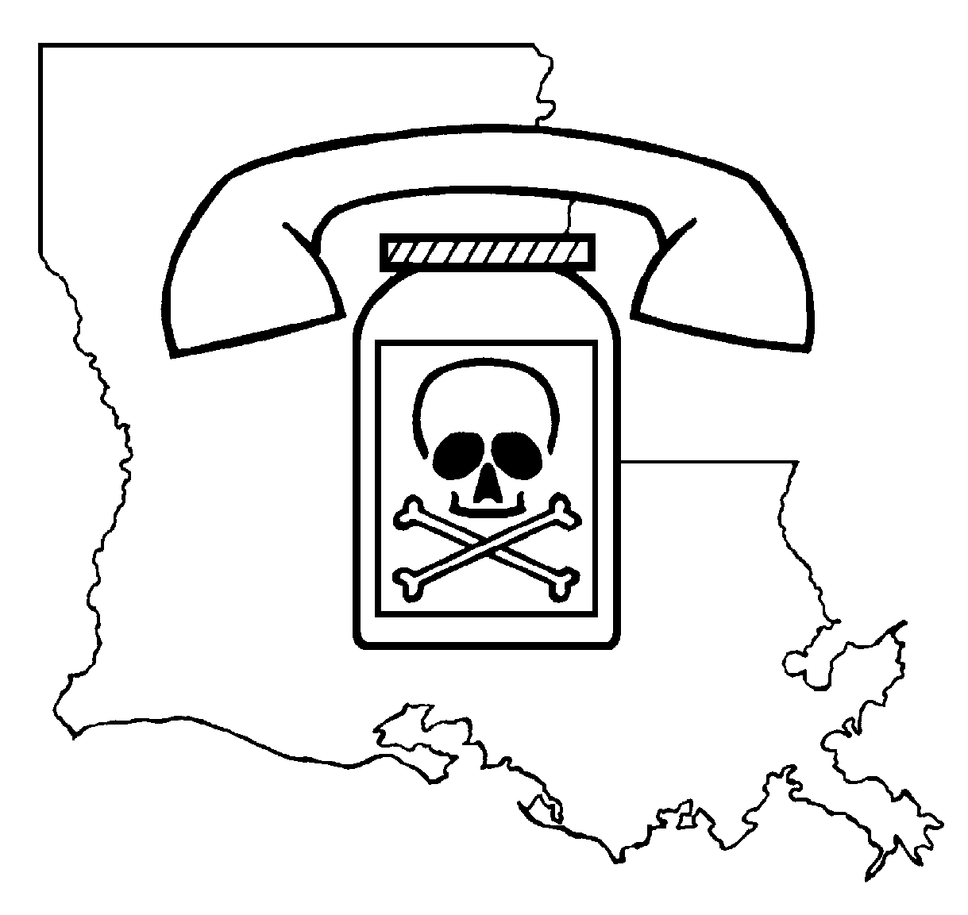
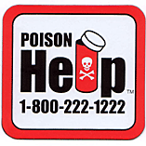
Louisiana Poison Center

Tuesday May 11, 2010
Deep Water Horizon Incident

(EXAMPLE) Daily Situation Report (SIT REP) # 5
Reporting Period: Friday May 7 – Monday May 10, 2010

Current Situation:

- Data collected by poison centers from spill related exposure calls includes but is not limited to callers name and contact number, patients name, age, weight, contact information, medical history, current medications, allergies, history of exposure (location, circumstances), time of exposure, site of exposure (workplace, residence, public area, other), route of exposure (dermal, inhalation, ingestion) reason for exposure ( occupational, unintentional, intentional, unknown) symptoms, treatment recommendations, management site, outcome (no effect, minor effect, major effect, death), and duration of effect (2 hours, 8 hours 24 hours, 3 days, 1 week, 1 month, anticipated permanent). Poison Centers are considered health care providers under the HIPAA Privacy Standards and all information provided is considered confidential.

- The LPC received 1 spill related exposure call over the weekend. Dermal exposure while walking on beach. Caller was from Alabama. Exposure site was in Alabama.

- The Louisiana Poison Center (LPC) is conducting an Advanced Hazardous Materials Life Support (AHLS) Course in Louisiana emergency preparedness Region 7 on May 10th and 11th 2010. This course is offered to a variety of responders and healthcare providers. Included in the lecture series are those devoted to hydrocarbons, halogenated hydrocarbons and corrosives.

- The LPC is providing oil spill related case data to the Louisiana Department of Epidemiology for statistical purposes and follow up where indicated.

Calls Received to Date LA MS AL

General Information Calls 31 5 0

Human Exposure Calls
Occupational 0 0 0
Non-Occupational 1(Dermal) 5 (vapor) 1(vapor)

Animal Exposure Calls 0 0 0

Media Requests 7 0 0

Louisiana Poison Center · 1455 Wilkinson Street · Shreveport, Louisiana 71103
Office: (318)813-3300 · Fax: (318)813-3315 · Poison Hotline 1-800-222-1222
Certified as a Regional Poison Center by the American Association of Poison Control Centers

Additional Information/Resources:
    - National Response Framework (NRF) - http://www.fema.gov/emergency/nrf/
    - National Response Center (NRC) - http://www.nrc.uscg.mil/nrchp.html
    - Federal Emergency Management Agency (FEMA) NIMS ICS Courses: http://www.fema.gov/emergency/nims/nims_training.shtm
    - Environmental Protection Agency (EPA) - http://www.epa.gov/superfund/programs/er/index.htm
    - Regional Response Team (RRT) 6 - http://www.epa.gov/Region6//6sf/respprev/rrt/rrt6.htm
    - Joint Response Team (JRT) - http://www.epa.gov/Border2012/indicators/response.html
    - Local Emergency Planning Committee (LEPC) - http://www.epa.gov/emergencies/content/epcra/epcra_plan.htm#LEPC
    - American Association of Poison Control Centers (AAPCC) - www.aapcc.org
    - Agency for Toxic Substances and Disease Registry (ATSDR) - http://www.atsdr.cdc.gov/2p- emergency-response.html
    - Centers for Disease Control (CDC) - http://www.bt.cdc.gov/
    - National Centers for Environmental Health (NCEH) - http://www.cdc.gov/nceh/emergency.htm
    - National Association of County and City Health Officials (NACCHO) - http://www.naccho.org/topics/emergency/
    - Emergency Management Assistance Compact (EMAC) - http://www.emacweb.org/

PCC Contacts by State (Non-emergencies):
Oklahoma PCC: 405-271-5062 New Mexico PCC: 505-272-4261
Arkansas PCC: 501-686-5532 Louisiana PCC: 318-813-3317
North Texas PCC, (Dallas) 214-850-1245; South Texas PCC, (San Antonio) 210-450-5100
Central Texas PCC, (Temple) 254-724-7405; South East Texas PCC, (Galveston) 409-772-9142
Texas Panhandle PCC, (Amarillo) 806-354-1611; West Texas Regional PCC, (El Paso) 915-534-3800

Original RRT6 Ad Hoc Work Group Members
Interim Activation Guidance for
Region 6 Poison Control Centers (Draft for RRT/JRT Region 6)
May 13, 2008 to January 27, 2009

Patrick Young, MS, RS
CDR, US Public Health Service
EPA/ATSDR
ATSDR Regional Rep., Region VI
1445 Ross Ave 6SF-T
Dallas, Texas 75202
214-665-8562 (office)
young.patrick@epa.gov

Jim Staves
EPA Region 6 Emergency Preparedness Coordinator
1445 Ross Avenue
Dallas, TX 75202
214-665-7433 (office)
214-665-2278 (fax)

Steve Mason
EPA Region 6 (6SF-PE)
Federal On-Scene Coordinator (OSC)
Regional Response Team Coordinator
1445 Ross Avenue
Dallas, TX 75202
214-665-2276 (office)

Maxine Jones
Public Health Analyst
Health Resources and Services Administration (HRSA)
Poison Control Program, 10C-06
5600 Fishers Lane
Rockville, MD 20857
301-443-6192 (office)
mjones@hrsa.gov

Randy Combs
Politeview, Inc.
214-707-3281 (cell)
www.politeview.com

John Temperilli
Vice President - Disaster Response
(RRT Industry Workgroup Lead)Garner Environmental Services, Inc.
1717 W. 13th Street
Deer Park, TX, 77536
281-930-4402 (office)
713-254-7985 (cell)
jtemperilli@garner-es.com
http://www.garner-es.com/

Howell Foster Pharm D., DABAT
Director, Arkansas Poison Control Center
Associate Professor
UAMS College of Pharmacy
University of Arkansas for Medical Sciences
4301 W. Markham St.
Little Rock, AR 72205
501-686-5532 (office)

Mark Ryan, RPh
Director
Louisiana Poison Control Center
LSU Health Sciences Center Shreveport
Department of Emergency Medicine
Section of Clinical Toxicology
1501 Kings Highway
Shreveport, LA 71130
318-675-6885 (office)
318-675-6878 (fax)
mryan@lsuhsc.edu

Randy Badillo, RN, BSN, CSPI
Clinical Supervisor
Oklahoma Poison Control Center
940 N.E. 13th Street, Room 3N3510
Oklahoma City, OK 73104
405-271-5454 (office)
405-271-1816 (fax)
Randal-Badillo@ouhsc.edu

Judy Whitfield
Program Coordinator
Texas Poison Center Network
Environmental & Injury Epidemiology & Toxicology
Epidemiology & Disease Surveillance Unit
Room T-713 Mail Code 1964
Department of State Health Services
Austin, Texas
512-458-7111 ext 6328 (office)
512-825-3810 (cell)
judy.whitfield@dshs.state.tx.us

John Villanacci, PhD
Manager
Texas Department of State Health Services
Environmental & Injury Epidemiology & Toxicology Branch
1100 W 49th Street, T713
Austin, TX 78756-3199
512-458-7111 ext 6175 (office)
512-458-7269 ext 6175 (office)
512-458-7111 ext 6175 (primary)
john.villanacci@dshs.state.tx.us
http://www.dshs.state.tx.us/epidemiology

Sharilyn Stanley, MD
Poison Program Coordinator
Commission on State Emergency Communications
512-800-5232 (office)
512-797-7411 (cell)
512-719-4561 (home)
sharilyns@csec.texas.gov

Brock R. Logan, KE5GJC
Legislative Liaison
Commission on State Emergency Communications
333 Guadalupe Street, #2-212
Austin, TX 78701-3942
512.305.6943 (office)
512.305.6937 (fax)
512-629-6143 (cell)
brock.logan@csec.state.tx.us

Norma Marrero
Poison Program Administrator
Commission on State Emergency Communications (Texas)
333 Guadalupe Street, Suite 2-212
Austin, TX 78701-3942
512-305-6940 (office)
512-751-5417 (cell)
norma.valle@csec.state.tx.us

John F. Haynes, Jr., MD
Associate Professor Emergency Medicine
and Medical Toxicology
Chief, Division of Medical Toxicology
Medical Director, West Texas Regional Poison Center
Texas Tech University HSC El Paso
Department of Emergency Medicine
4815 Almeda Avenue
El Paso, Texas 79905
915-534-3803 (office)
915-534-3809 (fax)
915-525-1109 (cell)
jhaynes8233@att.net

Stephen Borron, MD
Associate Medical Director
West Texas Regional Poison Center at Thomason Hospital
4815 Alameda Avenue
El Paso, Texas 79905
915-545-6551 (office)
915-534-3809 (fax)
202-841-7986 (cell)
Stephen.borron@ttuhsc.edu
Leo Artalejo, Pharm.D.
Managing Director
West Texas Regional Poison Center at Thomason Hospital
4815 Alameda Avenue
El Paso, Texas 79905
915-534-3801 (office)
915-534-3809 (fax)
915-479-2615 (cell)
leoa@poisoncenter.org
Wayne Snodgrass, MD, PhD
Medical Director
Southeast Texas Poison Center
3.112 Trauma Center
University of Texas Medical Branch
301 University Blvd.
Galveston, TX 77555-1175
409-772-9612 (office)
409-772-3917 (fax)
281-384-6686 (cell)
wsnodgra@utmb.edu

Jon D. Thompson, MS, DABAT
Managing Director
Southeast Texas Poison Center
3.112 Trauma Center
University of Texas Medical Branch
301 University Blvd.
Galveston, TX 77555-1175
409-772-3306 (office)
409-747-6200 (fax)
832-492-4050 (cell)
jdthomps@utmb.edu

Ryan Morrisey, MD
Medical Director
Central Texas Poison Center
2401 South 31st Street
Temple, TX 76508
254-724-7413 (office)
254-724-7408 (fax)
319-400-4219 (cell)
rmorrisey@swmail.sw.org

Hollie Blair, CSPI
Interim Managing Director
Central Texas Poison Center
2401 South 31st Street
Temple, TX 76508
254-724-7409 (office)
254-724-7408 (fax)
512-786-7465 (cell)
hblair@swmail.sw.org

Charlene Vincent
Application Specialist
Central Texas Poison Center
2401 South 31st Street
Temple, TX 76508
254-724-7403 (office)
254-724-7408 (fax)
254-541-3860 (cell)
cbvincent@swmail.sw.org

Shu Shum, MD
Medical Director
Texas Panhandle Poison Center
1501 S. Coulter
Amarillo, TX 79106
806-354-1632 (office)
806-354-1667 (fax)
806-345-1797 (pager)
shumshu@yahoo.com

Jeanie Jaramillo, PharmD
Managing Director
Texas Panhandle Poison Center
1501 S. Coulter
Amarillo, TX 79106
806-354-1611 (office)
806-354-1667 (fax)
806-672-0833 (cell)
Jeanie.jaramillo@ttuhsc.edu

Miguel C. Fernández, MD, FACEP, FAAEM, FACMT
Medical & Managing Director, South Texas Poison Center
Clinical Professor; University of Texas Health Science Center at San Antonio
7979 Wurzbach Rd, MSC 7849
San Antonio, Texas 78229-3900
210-450-5100 (office)
210-450-5110 (fax)
210-394-8900 (cell)
fernandezmc@uthscsa.edu
www.texaspoison.com

Lizette Villarreal, MA
Assistant Director
South Texas Poison Center
Faculty; University of Texas Health Science Center at San Antonio
7979 Wurzbach Rd, MSC 7849
San Antonio, Texas 78229-3900
210-450-5104 (office)
210-450-5110 (fax)
210-508-7381 (cell)
villarrealc@uthscsa.edu
www.texaspoison.com

Brett Roth, MD
Medical Director
North Texas Poison Center
25201 Harry Hines Blvd
Dallas, TX 75235
214-590-8443 (office)
214-59-5008 (fax)
214-797-7339 (cell)
brett.roth@UTSouthwestern.edu

Jorie Klein, RN
Managing Director
North Texas Poison Center
25201 Harry Hines Blvd
Dallas, TX 75235
214-590-8717 (office)
214-590-5008 (fax)
214-786-8296 (pager)
jorie.klein@phhs.org

Melody Gardner, RN, MSN, CCRN
Manager
North Texas Poison Center
25201 Harry Hines Blvd
Dallas, TX 75235
214-590-9010 (office)
214-590-5008 (fax)
214-580-1245 (cell)
melody.gardner@phhs.org

